(Approx. 756 words)

Family Tree Maker 2011 (Part 4)
Review by Mary Phillips, Secretary, Icon Users Group, MO
July 2011 issue, The ICON-Newsletter of the Interactive Computer Owners Network
www.iconusersgroup.org
mphillip1.mary (at) gmail.com

Tab 4 Source — Documenting our sources — recording where we get our facts about our families is one of the most important parts of our research because it proves to others which records our facts are based upon. If the documentation is detailed and correct, others will be able to follow our steps.

Each time information is added to your tree, a source and a source citation should be created. Example: In the Media section for J D Weaver, I have a scanned image of a lace shirt collar belonging to my great grandfather in a scrapbook created by a first cousin and in the possession of her son. Now I need to document where I found it.

A source contains unchanging facts about an item; for example, the author, title, and publication information for a book. In this case, it’s: J D Weaver’s Lace Collar.

Source Citations are individual details that explain where a fact is found, such as the page number of a book. In this case, Citation Detail is: Vivian G DeGraffenreid Sheffer’s scrapbook in the possession of James Talbert Sheffer, (and includes his address, phone number, and email address).

A third section is Citation text: The collar was in the scrapbook in an envelope with the writing "Letter from Grandpa Weaver" and "Grandpa Weaver's Collar". Jasper Dasher Weaver was Vivan's great grandfather. It was scanned 12 July 2004 by Mary Paula Jones Phillips.

Another example: Source — 1880 United States Federal Census.

Citation text — James Jones household, Kaufman, Kaufman County, Texas. Page 27, Enumeration District 39.

The same Source can be used with different Citation Texts, for example — Addison Weaver family, Kaufman, Kaufman County, Texas, Page 27, Enumeration District 39.

Citation text if found through Ancestry.com and merged with FTM: Ancestry.com and The Church of Jesus Christ of Latter-day Saints, 1850 United States Federal Census (Provo, UT, USA, Ancestry.com Operations Inc., 2010), www.ancestry.com, Database online. Year: 1880; Census Place: Kaufman, Texas; Roll: 1315; Family History Film: 1255315; Page: 135C; Enumeration District: 39; Image.

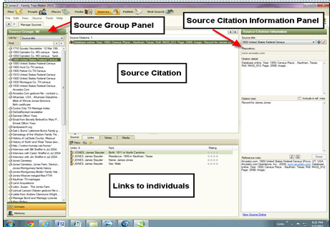

The Source tab above has four panels: 1) The Source Groups Panel can be sorted by Titles, People, or Repositories from the drop down menu. 2) The Source Citation Information Panel includes the Source Title, Repository, Citation text, and a Reference Note. 3) The Source Citation Panel shows what citations have been entered for a specific source; and 4) the tabs at the bottom show the individuals linked to the source, a notes tab, and a media tab.

Family Tree Maker lets you create sources in two ways: 1) Using one of the 170 templates based on Elizabeth Shown Mills’ book Evidence Explained (a preferred reference format for citing genealogy sources) or 2) a basic format. The templates make it relatively easy because you just have to fill in the fields with the information.


Adding a source for a fact can be done on the Family tab in the People Workspace. Do this:
1. In the right-side editing panel, click the New source citation button next to the fact to which you want to add a source. Then choose Add New Source Citation from the drop-down list.
2. The Add Source Citation window opens. Click either “Create a Source from a Template” or “Create a Source Using the Basic Format.”
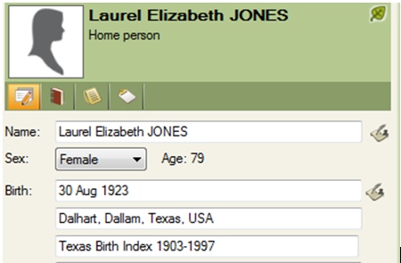
Sources and source citations can be created for both Facts and Media. Sources can also be added on the Person tab by:
1. Click on a fact in either the Fact view or the Timeline view.
2. In the Information Pane, click Add a source citation.
3. If the source already exists, click the drop– down list and select the correct title,
OR if not click New and enter the source information, citation detail, and citation text.

A Repository stores a group of sources. The most common repositories are libraries and courthouses or other buildings that house legal documents. Ancestry.com is a newer type of repository that houses electronic documents. Knowing the repository helps you to find the source more easily. Family Tree Maker makes it easy to record a repository and link several sources to it.

I strongly suggest you click on Help on the Menu bar and print out all the instructions for Source. The Companion Guide that is installed in PDF format with the program has some graphics.

The following websites have helpful information about creating source citations.

http://www.geneabloggers.com/Citations_Quick_Reference.pdf
http://www.tmgtips.com/srcetmpm.htm
http://cyndislist.com/citing/citations-in-genealogy/

